**Sentiment, Cryptocurrency and Inflation:**

**A Transmission Chanel in Bolivia[1]\***

**Osmar Bolivar[2]╪ Christian Huanto[3]♠**

**April 27, 2025**

**Abstract**

This paper examines the interplay between economic uncertainty sentiment, parallel cryptocurrency-based exchange rate, and inflation in Bolivia, leveraging high-frequency data and advanced econometric techniques. Following increased macroeconomic volatility from early 2023, Bolivia faced mounting pressure on its currency peg, leading to the rapid rise of stablecoins—particularly USDT—as alternative stores of value. Utilizing a dual methodological approach—a calibrated Dynamic Stochastic General Equilibrium (DSGE) model and a Bayesian Structural Vector Autoregression (BSVAR)—we identify a transmission mechanism where heightened uncertainty sentiment depreciates the parallel (digital) BOB/USDT exchange rate, amplifying inflationary pressures. Empirical impulse-response functions from daily data (January 2023 to April 2025) corroborate the model’s predictions, showing significant and persistent inflation effects driven by sentiment shocks. Moreover, our findings underscore the stabilizing potential of monetary policy, even within Bolivia’s constrained interest rate framework. This study offers critical insights for policymakers managing digital currency markets, emphasizing the need for real-time sentiment monitoring and proactive liquidity interventions to mitigate inflation risks.

**Keywords:** Economic Uncertainty, Sentiment Index, Cryptocurrency, Parallel Exchange Rate, Inflation, Monetary Policy, Bayesian SVAR, DSGE Model, Emerging Markets.

**JEL Codes:** E31, E42, E52, F31, G15.

1. **Introduction**

Macroeconomic stability in emerging markets hinges on the complex interplay between economic uncertainty, exchange rate dynamics, and inflationary pressures. Surges in uncertainty—whether from policy shifts, political turmoil, or external shocks—can unsettle expectations and behaviors, leading firms and households to postpone investment and consumption decisions (Bloom, 2009; Baker et al., 2016). Simultaneously, heightened uncertainty often triggers defensive actions such as currency substitution, as economic agents seek refuge in external stores of value, typically foreign currencies. This shift exerts pressure on domestic exchange rates and, through higher import costs and unanchored inflation expectations, propagates into domestic price levels. These dynamics are especially pronounced in emerging economies, where policy credibility is fragile and fixed exchange rate regimes can unravel rapidly.

The proliferation of digital currencies, particularly stablecoins like Tether (USDT), introduces additional complexity to this nexus. These assets facilitate capital mobility and value storage outside formal financial systems, giving rise to parallel exchange markets that operate beyond traditional regulatory oversight (Azar et al., 2024). Such “cryptoization” presents novel challenges for monetary authorities, complicating exchange rate management and amplifying volatility in financial markets.

While prior research has explored the effects of uncertainty shocks (Bloom, 2009, 2014; Baker et al., 2016; Berger et al., 2020; Nowzohour and Stracca, 2020) and exchange rate regimes in emerging markets, the interaction between economic uncertainty sentiment, cryptocurrency-based parallel exchange markets, and inflation remains underexplored. This study aims to address this gap, offering theoretical and empirical insights pertinent to contemporary monetary policy, particularly in the context of emerging economies.

Bolivia’s recent macroeconomic experience provides a compelling case study. Since 2011, the country maintained a de facto fixed exchange rate regime pegged at approximately 6.96 bolivianos per U.S. dollar, supported by commodity-driven foreign exchange reserves. This policy fostered low inflation, averaging around 2–3% annually. However, persistent fiscal deficits, declining gas exports, and dwindling reserves gradually eroded confidence in the peg by early 2023 (World Bank, 2025). As dollar scarcity intensified, a parallel (digital) exchange market emerged, with the boliviano trading above the official rate on cryptocurrency platforms like Binance. Despite direct interventions by the Central Bank of Bolivia (BCB) since March 2023 to supply dollars at the official rate (BCB, 2023), the parallel rate depreciated sharply, reaching Bs10–13 per USDT by late 2024.[4]

In response to these pressures, the BCB lifted its long-standing ban on cryptocurrencies in mid-2024, authorizing the use of stablecoins within the financial system (BCB, 2024). By year-end, over 250,000 Bolivians (approximately 6% of the adult population with formal income) held crypto-assets valued at an estimated USD 3 billion. This regulatory shift was further institutionalized when the 2025 General State Budget authorized government transactions in crypto-assets, reflecting the growing integration of digital currencies into Bolivia’s economic framework.[5]

Despite maintaining the official exchange rate peg, inflation surged to 9.97% year-on-year by late 2024, and further to 14.6% by March 2025.[6] This spike likely reflected both the pass-through from the depreciating parallel exchange rate ̶ which nearly doubled the official peg by April 2025 ̶ and the unanchoring of inflation expectations.[7] The Bolivian case illustrates how rising uncertainty sentiment, coupled with cryptocurrency-based parallel markets, can undermine inflation stability even without formal devaluation.

Accordingly, this paper proposes a theoretical framework and empirically evaluate the transmission mechanisms linking economic uncertainty sentiment, the parallel digital exchange rate, and inflationary dynamics in Bolivia. Leveraging novel daily-frequency data (2023–2025), we construct an Economic Uncertainty Sentiment Index derived from national news, track BOB/USDT exchange rates from online trading platforms, and estimate daily year-on-year inflation. This high-frequency dataset captures rapid feedback loops, crucial for analyzing modern financial markets and digital currency flows.

Our methodological framework integrates a Dynamic Stochastic General Equilibrium (DSGE) model calibrated to Bolivia’s institutional characteristics—with explicit channels for uncertainty sentiment shocks and parallel exchange rate dynamics—and Bayesian Structural Vector Autoregression (BSVAR) models estimated on daily data. The BSVAR employs sign and zero restrictions to identify structural shocks, allowing for empirical validation of the theoretical model. This dual approach bridges structural modeling with data-driven inference, providing a comprehensive analysis of the uncertainty sentiment parallel (digital) exchange rate inflation nexus.

The study contributes to the literature by incorporating digital parallel markets and uncertainty sentiment into models of inflation dynamics and exchange rate management—an increasingly relevant focus for emerging markets. From a policy perspective, the findings underscore the importance of real-time monitoring of market sentiment and parallel exchange rates. Even without formal devaluation, rising uncertainty and crypto-based parallel markets can destabilize inflation. Our results offer practical insights for central banks in emerging economies, suggesting that integrating sentiment and parallel market metrics into policy frameworks is essential for maintaining macroeconomic stability in the digital age.

The rest of the paper is structured as follows. Section 2 presents the DSGE-type theoretical model incorporating sentiment and a parallel exchange rate. Section 3 calibrates and simulates the DSGE model. Section 4 describes the high-frequency dataset, outlines the BSVAR empirical strategy, and reports the empirical findings, while Section 5 extends empirical analysis by examining monetary policy responses. Section 6 explores the possibility of reverse causality: whether shocks to the exchange rate and monetary policy interventions can themselves influence economic uncertainty sentiment in Bolivia. Lastly, Section 7 concludes with policy implications.

1. **Theoretical Foundation**

This section proposes a theoretical model designed specifically to understand and analyze the current Bolivian economic context, where the use of USDT cryptocurrency has significantly increased, establishing a parallel digital exchange market. Central to our analysis is the hypothesis that this BOB/USDT cryptocurrency-based parallel exchange rate is predominantly driven by shifts in economic uncertainty sentiment. Furthermore, we posit that fluctuations in economic uncertainty sentiment, either directly or indirectly via their influence on the cryptocurrency-based exchange rate, significantly impact inflation dynamics. Consequently, this theoretical foundation will serve as the basis for subsequent simulation-based and empirical evaluations.

**Standard New Keynesian Core and Behavioral Augmentations:** We base our theoretical setup on the canonical New Keynesian paradigm, which consists of following fundamental components:

1. *Forward-looking households* that optimize intertemporal consumption decisions, leading to a standard Euler equation linking the output gap to expected future economic conditions and real interest rates.
2. *Calvo-type nominal rigidities* capturing staggered price adjustments, thus generating intrinsic inertia in price-setting and inflation dynamics.
3. A *Taylor-type monetary policy rule* describing how the central bank adjusts nominal interest rates smoothly in response to deviations of inflation and the output gap from their target values.

To enhance realism and empirical relevance, we introduce two additional behavioral elements:

1. *Sentiment-driven uncertainty:* Shifts in optimism or pessimism derived from news or economic signals influence precautionary savings and risk premiums, reflecting behavioral insights as outlined by Milani (2017) and Gupta (2025).
2. *Sticky expectations*: Price-setting incorporates backward-looking components as firms partially index prices to past inflation, following the hybrid Phillips curve formulation of Basarac et al. (2011), capturing bounded rationality and informational rigidities.

These extensions ensure our model retains core New Keynesian properties, enriched by realistic behavioral dimensions particularly pertinent for emerging market economies such as Bolivia.

**Aggregate Demand (IS Curve) under Uncertainty:** Households maximize expected lifetime utility given by:

subject to an intertemporal budget constraint. Linearizing the Euler equation around a zero-inflation steady state and defining the output gap

where captures output-gap persistence (reflecting habits or adjustment costs), measures intertemporal substitution, and quantifies the contractionary effect of increased sentiment-driven uncertainty on aggregate demand, consistent with Miescu (2023).

**Inflation Dynamics and the Hybrid Phillips Curve:** Price-setting firms face Calvo-type constraints, where a fraction cannot adjust prices each period. Among resetting firms, a proportion partially index to past inflation, reflecting sticky expectations. The resulting hybrid New Keynesian Phillips Curve (NKPC) is:

with , representing price rigidity and real marginal costs (with labor supply elasticity ), and capturing exchange-rate pass-through from parallel (digital) market fluctuations , reflecting the import price channel in open economies (Ascari et al., 2023).

**Monetary Policy and the Taylor Rule**: Monetary policy is represented through a smoothed Taylor rule:

where ensures inflation determinacy via the Taylor principle (*Clarida et al., 1999*), captures output-gap responsiveness, and reflects policy inertia.

Although the Central Bank of Bolivia (BCB) does not target interest rates as its main policy tool, the inclusion of a Taylor rule provides normative insights into how monetary policy could respond in the current environment. The emergence of a parallel digital exchange market (BOB/USDT), driven by rising USDT usage and shifts in economic uncertainty sentiment, affects inflation dynamics via exchange rate pass-through.

This specification allows us to explore how an interest rate reaction function, even if theoretical, could mitigate inflationary pressures and output fluctuations stemming from cryptocurrency-based exchange rate movements. It highlights the potential role of mone- tary policy in stabilizing inflation and output when faced with sentiment-driven currency pressures outside formal central bank mechanisms—this assumption is empirically con- firmed in section 5.

**Parallel Exchange Rate Dynamics and Risk Premium:** The parallel (digital) USDT/BOB exchange rate, a key element in Bolivia’s evolving financial landscape, is modeled as:

where denotes the BOB/USDT exchange rate, captures sensitivity to economic uncertainty sentiment , and represents a stochastic risk premium.

We adopt a random walk structure (unit root) without a mean-reverting term, justified by two core features: i) Exchange rates—particularly in cryptocurrency markets—display non-stationary behavior and persistent shocks, as established in empirical studies (Almeida and Gonc¸alves, 2024). The BOB/USDT rate, driven by decentralized trading and devoid of macroeconomic policy anchors, exhibits similar dynamics; ii) Consistent with bounded rationality and noise trader frameworks (Shleifer and Summers, 1990), cryptocurrency- based exchange rates respond predominantly to sentiment shifts and speculative flows, rather than traditional fundamentals, making permanent shock effects plausible.

Sentiment-driven uncertainty () is crucial for modeling this cryptocurrency-based exchange rate. Unlike conventional regimes, which reflect macroeconomic fundamentals such as interest rate differentials or trade balances, Bolivia's parallel digital exchange market operates with limited institutional anchoring, amplifying its sensitivity to perceptions of economic and financial risk. Elevated uncertainty increases demand for USDT as a safe-haven asset, depreciating the Boliviano (BOB) relative to the stablecoin.

The stochastic risk premium follows an autoregressive process:

where captures premium persistence, and denotes exogenous shocks, such as sudden capital outflows, global financial market volatility, or unexpected policy adjustments independent of domestic sentiment.

This specification aligns with observed dynamics in cryptocurrency markets, where ex- change rate movements reflect both endogenous sentiment and exogenous shocks (Almeida and Gon¸calves, 2024). By explicitly linking the parallel exchange rate to these drivers, the model captures the volatility and speculative behavior characteristic of cryptocurrency- based exchange systems (Corbet et al., 2018).

Furthermore, this framework reflects recent evidence that stablecoins like USDT increasingly serve as safe-haven assets in emerging markets experiencing macroeconomic instability and currency crises (Liao and Caramichael, 2022; Ante et al., 2023). Incorporating these elements allows for a more precise representation of Bolivia’s parallel digital exchange rate response to uncertainty shocks, establishing a coherent transmission mechanism to inflation and output dynamics within the broader macroeconomic framework.

**Sentiment Dynamics and Behavioral Uncertainty:** Economic sentiment follows a persistent autoregressive process:

where captures persistence, and represents exogenous news shocks. This structure reflects the behavioral view that waves of optimism or pessimism, driven by narratives or geopolitical events, not necessarily evolve related to economic fundamentals (Gupta, 2025; Milani, 2017).

We intentionally exclude macroeconomic indicators (e.g., output gap) as determinants of sentiment for two reasons. First, empirical studies show that sentiment often fluctuates independently of fundamentals and can precede economic changes (Baker et al., 2016). Second, modeling sentiment as exogenous avoids feedback loops that could confound the identification of pure uncertainty shocks. This ensures a clearer analysis of how sentiment independently drives exchange rate dynamics and inflation, particularly relevant in Bolivia’s context of a cryptocurrency-based parallel market.

**Comprehensive Transmission Channel and Behavioral Insights:** Equations (1)–(6) constitute an integrated framework elucidating how sentiment-driven uncertainty propagates through the economy:

1. A positive sentiment shock () elevates economic uncertainty (), inducing precautionary saving that reduces aggregate demand () and simultaneously triggers currency depreciation ().
2. Currency depreciation increases import costs, raising domestic inflation () via exchange-rate pass-through (). Sticky expectations (via ) amplify inflation persistence and inertia.
3. Independent risk premium shocks () further influence exchange rate dynamics, highlighting separate exogenous channels distinct from sentiment-driven mechanisms.

This theoretical setup integrates traditional New Keynesian features (forward-looking behavior, nominal rigidities, and a monetary policy rule) with empirically relevant behavioral elements (sticky expectations and uncertainty sentiment). This combination provides a coherent basis to empirically evaluate Bolivia’s recent experiences of cryptocurrency-based exchange rate instability and inflationary pressures.

1. **Simulations**
   1. **DSGE Model**

To evaluate the proposed transmission mechanism within a general equilibrium framework, we calibrate and simulate a Dynamic Stochastic General Equilibrium (DSGE) model derived from the theoretical structure outlined in Section 2. This model captures the interactions between economic uncertainty sentiment, the parallel (digital) BOB/USDT exchange rate, and inflation, specifically tailored to Bolivia's macroeconomic environment.

The model's endogenous variables include the output gap (), inflation (), the nominal interest rate (), the BOB/USDT parallel digital exchange rate (), the economic uncertainty sentiment index (), and the risk premium component (). The system is driven by four exogenous shocks: (i) uncertainty sentiment shock (), (ii) risk premium shock (), (iii) cost-push (markup) shock (), and (iv) monetary policy shock ().

The model's equilibrium conditions are summarized as follows:

These equations describe the dynamics of aggregate demand (7), inflation (8), monetary policy (9), exchange rate determination (10), sentiment (11), and the risk premium (12).

Parameters are calibrated using empirical studies on Bolivia and broader emerging market economies (for a monthly-frequency model). Table 1 summarizes the calibrated values:

|  |  |  |
| --- | --- | --- |
| Parameter | Value | Reference |
| Monthly discount factor | 0.997 | Galí (2015) |
| CRRA elasticity | 2.225 | Valdivia (2016) |
| Sensitivity to real interest rate | 0.449 | — |
| Taylor rule output response | 6.907 | Valdivia and Montenegro (2009) |
| Taylor rule inflation response | 1.25 | Valdivia and Montenegro (2009) |
| Interest-rate smoothing | 0.846 | Mendieta-Ossio (2010) |
| NKPC slope | 0.242 | Mendieta-Ossio (2010) |
| Exchange-rate passthrough to inflation | 0.193 | Mendieta-Ossio (2010) |
| Sentiment effect on output | 0.074 | Calibrated to fit empirical correlation |
| Sentiment effect on exchange rate | 0.100 | Calibrated to fit empirical correlation |
| Persistence of sentiment AR(1) | 0.600 | OLS estimate |
| Persistence of risk premium AR(1) | 0.790 | Zeballos Coria et al. (2018) |
| Forward weight in hybrid NKPC | 0.497 | Valdivia and Montenegro (2009) |
| Backward weight in hybrid NKPC | 0.458 | Valdivia and Montenegro (2009) |
| Persistence of output gap | 0.500 | Mendieta-Ossio (2010) |

The DSGE model is solved under rational expectations. Impulse-response functions (IRFs) are generated to simulate the effects of sentiment shocks, risk premium (exchange rate) shocks, and monetary policy shocks on output, inflation, and the exchange rate (subsection 3.2 below).

* 1. **Simulated Transmission Channel**

This subsection presents preliminary evidence from the calibrated DSGE model, illustrating the hypothesized transmission mechanisms linking economic uncertainty sentiment, the parallel (digital) exchange rate, and inflation in Bolivia’s macroeconomic context. The IRFs simulate dynamic responses to structural shocks over a 24-month horizon, offering insights into the interplay between these variables.

Figure 1 illustrates the effects of an economic uncertainty sentiment shock (). The sentiment index () rises immediately and persists due to its autoregressive structure, contracting the output gap () through the IS equation term , reflecting reduced aggregate demand. Concurrently, the parallel (digital) exchange rate depreciates following , as risk aversion increases demand for stablecoins.

This depreciation feeds inflation through exchange rate pass-through captured by in the New Keynesian Phillips curve (NKPC), while the contracting output gap exerts deflationary pressure via , producing a temporary trade-off between inflationary and deflationary forces. The nominal interest rate () adjusts gradually under a Taylor rule, reflecting monetary policy smoothing (), as the central bank responds to the contraction in output and rising inflation.

These IRFs suggest that uncertainty shocks induce transitory but volatile responses. Inflation rises initially but moderates as deflationary forces from output contraction take hold. The output gap contracts sharply and recovers gradually, aligning with theoretical expectations that uncertainty shocks trigger short-to-medium-term fluctuations without permanent dislocations.

|  |  |
| --- | --- |
|  |  |
| 1. Response of inflation | 1. Response of the output gap |
|  |  |
| 1. Response of monetary policy rate | (d) Response of exchange rate |
| Figure 1: IRFs: Economic Uncertainty Sentiment Shock | |

Figure 2 presents the responses to an exchange rate risk premium shock (), which directly depreciates the parallel exchange rate (). This depreciation elevates inflation through the NKPC pass-through term , with inflation peaking around two months post-shock before gradually stabilizing. The output gap () initially expands, likely reflecting exchange-rate-induced competitive effects, but contracts as higher import costs weigh on aggregate demand.

|  |  |
| --- | --- |
|  |  |
| 1. Response: inflation | 1. Response: Output Gap |
|  | |
| (c) Response: Interest Rate | |
| Figure 1: IRFs: Risk Premium Shock ( Exchange Rate) | |

The monetary policy rate () responds by rising to counter inflationary pressures, before declining as inflation subsides, reflecting the Taylor rule’s responsiveness to inflation. These responses highlight the pivotal role of the exchange rate risk premium as a transmission channel, underscoring inflation and output sensitivity to exchange rate fluctuations in Bolivia’s constrained monetary setting.

Finally, Figure 3 displays the effects of a monetary policy shock (), modeled as an exogenous increase in the nominal interest rate () via the Taylor rule. The persistent policy parameter () amplifies the effect, influencing both the current level and expectations of future rates. The higher contracts the output gap through , reducing aggregate demand and exerting downward pressure on inflation. Due to smoothing, the inflation response is initially muted but becomes more prominent over time.

Despite the model does not explicitly tie the exchange rate to monetary policy, it is reasonable to expect that higher interest rates would indirectly stabilize the domestic currency against depreciation in the parallel market. However, these simulations suggest that exchange rate stabilization via interest rate policy alone may be limited, indicating that broader interventions could be necessary.

|  |  |
| --- | --- |
|  |  |
| 1. Response of inflation | 1. Response of the Output Gap |
| Figure 3: IRFs: Monetary Policy Shock | |

While the DSGE model provides theoretical insights into the transmission channel, section 4 complements this by offering data-driven validation. Using daily data for Bolivia (2023–2025), it captures real-time interactions between uncertainty sentiment, the parallel BOB/USDT exchange rate, and inflation, refining and enhancing the simulated findings.

1. **High-Frequency Empirical Analysis**

This section presents the empirical evaluation of the theoretical framework developed in Section 2, leveraging daily-frequency data to capture the dynamics of Bolivia’s parallel digital exchange market and its interactions with economic uncertainty sentiment and inflation. The rise of cryptocurrency-based exchange mechanisms, particularly the USDT/BOB parallel rate, represents a recent phenomenon that commenced in early 2023. Given the limited time span and rapidly evolving nature of this market, conventional econometric analyses using lower-frequency data (e.g., monthly or quarterly) are insufficient to fully characterize these high-frequency interactions. Accordingly, this research innovates by constructing and employing daily measures of the USDT/BOB exchange rate, a novel economic uncertainty sentiment index, and daily inflation estimates specific to Bolivia. Through the application of a Bayesian Structural Vector Autoregressive (BSVAR) model at the daily frequency, this section empirically tests the transmission mechanisms outlined in the theoretical model, offering new insights into the role of sentiment and cryptocurrency-based exchange rates in shaping inflation dynamics under constrained monetary policy environments.

* 1. **Data**

Given that Bolivia’s parallel digital exchange market, led by the USDT/BOB cryptocurrency rate, emerged only in early 2023, conventional low-frequency datasets are inadequate for capturing the short-term dynamics associated with this market. To address this limitation, we compile a novel daily dataset spanning from January 1, 2023, to April 11, 2025. The dataset includes three key variables: (i) the cryptocurrency-based exchange rate (BOB/USDT) year-on-year depreciation, (ii) an economic uncertainty sentiment index, and (iii) daily year-on-year inflation estimates for Bolivia. Each of these variables has been specifically constructed to reflect high-frequency economic conditions and to support robust identification of short-term relationships within the BSVAR framework.

|  |
| --- |
|  |
| Figure 4: Daily-Frequency Endogenous Variables |

Figure 4 shows these three (endogenous) variables. The following paragraphs detail the data sources, construction methodologies, and rationale for each series.

**Cryptocurrency-Based Exchange Rate y-o-y Depreciation:** The daily digital exchange rate series is constructed from the BOB/USDT average price reported by Binance’s peer-to-peer (P2P) platform, the most widely used mechanism for cryptocurrency transactions in Bolivia. Binance’s P2P market serves as the principal venue for local currency-to-stablecoin (USDT) conversions and is regularly monitored by the Central Bank of Bolivia, which publishes daily reference rates based on this platform.

While data coverage extends from January 2023 onward, the early months of 2023 exhibit sporadic missing observations due to limited trading activity during the market’s initial adoption phase. To address these gaps, we apply a time-based interpolation method to estimate the missing values.[8] This approach is appropriate for high-frequency time series, particularly under the assumption of low volatility in the BOB/USDT rate during this period. Early 2023 market conditions were characterized by gradual adoption and low trading volumes, resulting in stable exchange rates with minimal daily fluctuations. Consequently, time-based interpolation offers a parsimonious and robust solution, filling data gaps without introducing artificial volatility or distorting subsequent calculations.

The daily year-on-year depreciation of the Boliviano relative to the USDT (variable in section 4.2) is computed as the difference between the BOB/USDT exchange rate at day and its value at day . This metric captures persistent trends in the parallel exchange rate, aligning with our objective to assess long-term depreciation dynamics in response to uncertainty sentiment. To compute year-on-year changes for observations in 2023, exchange rate values for corresponding days in 2022 are required. Given that the BOB/USDT market did not exist prior to 2023, we rely on the monthly parallel market exchange rate BOB/USD reported by the Unidad de Análisis de Políticas Sociales y Económicas (UDAPE) as a proxy for the earlier period. The UDAPE series is interpolated to a daily frequency to fill intra-month gaps.

We believe this approach is valid for two reasons. First, in 2022, the parallel market exchange rates for BOB/USD and the emerging BOB/USDT market were functionally equivalent, both operating outside formal monetary mechanisms and reflecting market-based valuations. Second, the relatively stable monthly variations in Bolivia’s parallel market during 2022 justify time-based interpolation, which preserves underlying exchange rate trends without introducing spurious high-frequency noise. This ensures methodological consistency and enables accurate measurement of year-on-year depreciation, a central variable in the empirical assessment of cryptocurrency-based exchange rate dynamics within Bolivia’s evolving cryptocurrency landscape.

**Economic Uncertainty Sentiment Index:** Uncertainty, as defined by Bloom (2014), reflects the lack of clarity regarding future events and their potential economic conse- quences. This absence of foresight constrains decision-making for individuals and firms, affecting investments, hiring, and expansion, particularly during periods of macroeco- nomic instability. Baker et al. (2016) further emphasize the role of uncertainty surround- ing economic policy decisions, which can disrupt economic stability and influence behav- ioral responses. Thus, uncertainty is widely recognized as a key determinant of economic fluctuations, capable of amplifying or mitigating shocks depending on institutional and macroeconomic conditions.

While traditional proxies for uncertainty, such as stock market or GDP volatility, remain prevalent, Baker et al. (2016) introduce a more direct approach, constructing an index based on the frequency of terms related to the economy, policy, and uncertainty in newspaper articles. This methodology captures shifts in perceived uncertainty by analyzing media content.

Despite the global proliferation of uncertainty indicators, Bolivia lacks a dedicated time series to measure economic uncertainty. To address this gap, we construct a daily-frequency Economic Uncertainty Sentiment Index for Bolivia, adapting the methodology of Baker et al. (2016) to the national context. The index measures the frequency of key terms across three thematic categories—Politics, Economy, and Uncertainty—in economic news articles from three Bolivian online outlets: El Deber, ERBOL Noticias, and Bru´jula Digital. The selection of keywords (see Appendix B) follows established economic policy uncertainty literature and adheres to standard content auditing guidelines.[9]

Data were collected via automated web scraping, providing systematic access to article headlines, content, and publication dates. The final dataset comprises 12,480 articles with daily coverage, ensuring comprehensive representation of Bolivia’s economic news land- scape. Data extraction incorporated duplicate filtering and complied with each outlet’s usage policies, ensuring methodological rigor and reproducibility.

For each article i, the frequency of keywords in each category is computed. Letting P, E, and U denote the sets of keywords for politics, economy, and uncertainty, respectively:

The total frequency of key terms for article is: f(i) = .

Articles are then aggregated by day. For each day , we compute the total number of articles published, , and the total sum of keyword mentions, . The preliminary daily economic uncertainty index is defined as: .

Given the inherent volatility of sentiment measures, the preliminary index $\text{U}_t$ is smoothed using a 30-day moving average to capture medium-term trends while filtering out noise. The resulting series is then standardized to express uncertainty in units of standard deviations, ensuring temporal comparability. The final *Economic Uncertainty Sentiment Index* (), used in the empirical analysis (Section 4.2), is defined as:

where is the 30-day moving average of , and and denote the mean and standard deviation of the smoothed series, respectively.

Figure 5 provides a schematic overview of the construction process for the Economic Uncertainty Sentiment Index.

|  |
| --- |
|  |
| Figure 5: Construction of the Economic Uncertainty Sentiment Index |

**Daily y-o-y Inflation:** We estimate daily-frequency year-on-year CPI inflation, $\hat\pi_t$, by adapting the two-step machine learning framework of Bolivar (2025) to our context, utilizing 146 raw daily predictors without prior feature selection.

In the first stage, *mixed-frequency alignment*, each daily series is aggregated into monthly-equivalent features:

where denotes the set of days within month . These aggregated predictors are then merged with the official monthly CPI y-o-y inflation series , producing a monthly training and validation dataset spanning January 2010 to March 2025.

In the second stage, *modeling and forecasting*, we randomly partition the monthly dataset into 80% for training and 20% for validation, apply z-score normalization, and fit a suite of machine learning models—Ridge, Lasso, Random Forest, Gradient Boosting, AdaBoost, Extra Trees, and forecast combination schemes. Hyperparameters are selected via 5-fold cross-validation. The best-performing model, , identified by mean squared error (MSE) and on the hold-out set, is then deployed directly on the unaggregated 146-dimensional daily feature vectors for January 1, 2023, through April 11, 2025, yielding daily inflation estimates .

This methodology is particularly suited for the present analysis for three key reasons. First, the monthly training targets align with the same underlying daily processes that generate the high-frequency predictors, ensuring internal consistency. Second, distributional tests confirm that the aggregated daily predictors are statistically comparable to their monthly counterparts, validating the mixed-frequency alignment.[10] Third, the absence of prior feature selection allows us to fully leverage the informational richness of wholesale prices, financial indicators, and commodity prices—critical in Bolivia’s evolving USDT/BOB parallel market, where structural relationships may be subject to rapid changes.

Appendix A presents the resulting daily-frequency CPI inflation estimates from January 2010 to April 2025, alongside forecast evaluation metrics. On the validation set, the final model achieves an MSE of 0.154 and an of 0.974, indicating strong predictive accuracy.

* 1. **Daily-Frequency BSVAR Model**

This subsection presents the specification and identification strategy of the Bayesian Structural Vector Autoregressive (BSVAR) model, which empirically evaluates the high-frequency interactions between economic uncertainty sentiment, the cryptocurrency-based parallel exchange rate, and inflation. The endogenous variables, observed daily from January 1, 2023, to April 11, 2025, are defined as follows: (i) the year-on-year depreciation of the BOB/USDT exchange rate, ; (ii) the standardized economic uncertainty sentiment index (expressed in standard deviation units), ; and (iii) daily year-on-year inflation estimates for Bolivia, . The model incorporates nine lags, as determined by the Akaike Information Criterion (AIC), which accounts for both weekly cycles and short-term persistence inherent in daily data.

**BSVAR Model Specification:** The reduced-form VAR is specified as:

where and is the vector of reduced-form residuals. The Bayesian framework is adopted due to the relatively short time span of the daily dataset, ensuring robust estimation through the incorporation of prior information. We employ the Hierarchical Minnesota prior, following Giannone et al. (2015), which shrinks higher-order lag coefficients toward zero while allowing for persistence in highly autocorrelated series. This approach mitigates overfitting risks and stabilizes parameter estimates under potential near-unit-root behavior.

Estimation is conducted via Markov Chain Monte Carlo (MCMC) sampling, drawing from the posterior distributions of the VAR parameters and structural shocks. A sufficiently large number of posterior draws (i.e., 50,000 after 5,000 burn-in and thinning) ensures convergence and reliable inference. The reduced-form parameter posterior follows a conjugate Normal-Inverse-Wishart distribution, while structural identification is achieved through post-estimation rotation methods consistent with the imposed restrictions, as outlined by Arias et al. (2018).

**Structural Shock Identification Scheme (Sign and Zero Restrictions):** To identify structural shocks, we impose contemporaneous sign and zero restrictions on the impact responses, consistent with the theoretical framework. Three structural shocks are identified: (i) an Uncertainty Sentiment shock, (ii) a Cryptocurrency-based Exchange rate shock, and (iii) a Supply Inflation shock. Restrictions are applied to the immediate (impact) responses as follows:

For the sentiment shock, we impose a positive sign on the exchange rate response, capturing the depreciation of the BOB in response to rising uncertainty. This reflects the mechanism where heightened uncertainty induces capital outflows or dollar hoarding, depreciating the local currency (Glebocki and Saha, 2024). The impact on inflation remains unrestricted, recognizing the ambiguous short-run effects of uncertainty on prices, while the sentiment index itself rises by construction.

For the cryptocurrency-based exchange rate shock, we impose a positive sign on inflation, reflecting exchange rate pass-through effects, and a zero restriction on the sentiment index, assuming that contemporaneous exchange rate fluctuations do not immediately alter uncertainty sentiment. This distinction allows for delayed sentiment responses, isolating the direct inflationary impact of exchange rate shocks.

For the supply inflation shock, which captures price pressures unrelated to sentiment or exchange rate movements (e.g., supply shocks), we impose zero restrictions on the immediate responses of both the exchange rate and sentiment index, ensuring that this shock exclusively affects inflation contemporaneously.

Formally, these on-impact restrictions are expressed as:

where is the impact multiplier matrix. These restrictions are imposed only at the contemporaneous horizon, allowing subsequent responses to *evolve freely* according to the VAR dynamics. The identification strategy ensures that structural shocks are uniquely labeled and aligned with theoretical expectations, facilitating inference on the dynamic interplay between sentiment, cryptocurrency-based exchange rate movements, and inflation in Bolivia’s high-frequency context.

* 1. **Empirical Transmission Channel**

This section evaluates whether the hypothesized transmission channel—*uncertainty sentiment* *BOB/USDT* *depreciation* *inflation*—is empirically supported, as postulated in the theoretical and simulation frameworks (Sections 2 and 3). Using the daily-frequency BSVAR model described earlier, we estimate impulse-response functions (IRFs) to assess this channel. Median responses from the posterior distributions represent the IRF estimates, while the 32nd and 68th percentiles provide Bayesian credible intervals.

The first link in the transmission chain examines whether economic uncertainty sentiment significantly affects the parallel (digital) BOB/USDT exchange rate. Figure 6 illustrates that a one-standard-deviation sentiment shock induces an immediate BOB 0.04 depreciation in the exchange rate, consistent with heightened risk aversion and flight-to-quality behavior. This depreciation amplifies over time, reaching BOB 0.10 after one week, BOB 0.23 after one month, and stabilizing near BOB 0.31 by three months post-shock. All effects are statistically significant within the Bayesian credible bands. The magnitude of this response can be contextualized by referring to the intervention and subsequent bankruptcy of Banco Fassil in March–April 2023, one of the most prominent financial shocks within the period of analysis. During this episode, the uncertainty sentiment index surged to 1.7 standard deviations above its mean, suggesting that real-world shocks of this scale are comparable, if not larger, than the one-standard-deviation sentiment shock modeled here. This provides an economically relevant benchmark for interpreting the model’s estimates of sentiment-driven exchange rate depreciation.

|  |
| --- |
|  |
| Figure 6: Sentiment ( Uncertainty) Shock BOB/USDT y-o-y Depreciation |

The second step assesses how uncertainty sentiment and BOB/USDT depreciation influence inflation dynamics. Figure 7-(a) shows that following a sentiment shock, inflation initially declines over the first week, consistent with a contractionary demand-side effect predicted by the theoretical framework. However, from the second week onward, inflation reverses and enters a sustained upward trajectory due to the exchange-rate pass-through mechanism. Specifically, a one-standard-deviation sentiment shock raises y-o-y inflation by 0.25 percentage points after 30 days, with the effect continuing to accumulate, reaching 0.60 percentage points after 90 days. This persistence highlights the capacity of transitory uncertainty shocks to produce lasting inflationary pressures, a dynamic captured effectively by the BSVAR framework's accommodation of non-stationary processes.

|  |  |
| --- | --- |
|  |  |
| (a) Sentiment ( Uncertainty) Shock | (b) BOB/USDT Depreciation Shock |
| Figure 7: Shock y-o-y Inflation Forecast | |

Figure 7-(b) depicts the inflationary consequences of a direct BOB/USDT depreciation shock. Following an initial minor decline in inflation between days 3–5, inflation accelerates thereafter. A BOB 1 depreciation increases y-o-y inflation by 0.56 percentage points after 30 days, and this effect amplifies to 1.39 percentage points after 90 days. These findings reinforce the significant role of---digital---exchange rate pass-through in Bolivia’s inflation dynamics, particularly in the context of a parallel, sentiment-driven exchange rate regime.

For robustness, we re-estimate the BSVAR model with 30 lags to account for intra-month seasonality and ensure that dynamics beyond daily and weekly patterns are captured. The results, reported in Appendix C, confirm the main findings of this section, providing additional confidence in the stability of the identified transmission mechanisms.

1. **Monetary Policy Under the Evaluated Transmission Channel**

This section extends the BSVAR model from subsection~\ref{subsec:daily_bsvar} by incorporating the interbank interest rate as a proxy for monetary policy. Although the Central Bank of Bolivia (BCB) does not explicitly target interest rates as its primary instrument, it indirectly manages financial system liquidity—its operational objective—through interventions in the interbank market. This approach positions the interbank rate as a valid empirical proxy to assess monetary policy reactions, particularly within the high-frequency framework adopted here, and against the backdrop of Bolivia's emergent parallel digital exchange market (BOB/USDT), which is largely driven by shifts in economic uncertainty sentiment.

We expand the original three-variable BSVAR () by introducing the year-on-year difference in the interbank interest rate () alongside a corresponding monetary policy shock. The identification strategy follows the structure outlined in subsection 4.2, augmented to reflect the role of the interbank rate and monetary policy. The extended structural shock identification scheme is as follows:

Here, denotes the impact multiplier matrix (the inverse of the contemporaneous coefficient matrix ). This identification structure ensures that:

* A *sentiment shock* depreciates the exchange rate on impact but leaves the interest rate unaffected contemporaneously.
* An *exchange rate shock* raises inflation instantly but does not affect sentiment or the interest rate on impact.
* An *inflation shock* has no immediate influence on sentiment, exchange rate, or interest rate.
* A *monetary policy shock* directly increases the interest rate, while its effects on the other variables remain unrestricted.

This setup aligns with the theoretical framework and reflects the high-frequency characteristics of the data. It captures the delayed policy responses of the BCB while allowing for immediate adjustments via the interbank rate.

Figure 8 presents the IRFs of the interbank interest rate to the structural shocks. Panel~(a) shows that a one-percentage-point increase in inflation due to a supply shock prompts an immediate rise in the interbank rate, peaking at approximately 0.37 percentage points after one week. This initial tightening reflects a standard policy response aimed at stabilizing inflation, consistent with Taylor-rule dynamics. However, the adjustment follows an inverted-U trajectory, with the interbank rate gradually declining and falling below pre-shock levels (by about 0.12 percentage points) approximately 35 days post-shock. This transient response suggests that Bolivia's monetary policy framework, focused on liquidity management rather than sustained interest rate targeting, reacts flexibly to inflationary pressures without committing to prolonged rate hikes.

|  |  |
| --- | --- |
|  | |
| (a) Supply ( ) Shock | |
|  |  |
| (b) Sentiment ( Uncertainty) Shock | (c) BOB/USDT Depreciation Shock |
| Figure 8: Shock y-o-y Interest Rate | |

Panel (b) indicates that a one-standard-deviation sentiment shock induces a temporary decline in the interbank rate, likely reflecting an accommodative stance to offset contractionary demand effects. This easing dissipates within approximately 30 days, consistent with short-term liquidity management practices that prioritize macro-financial stability amid uncertainty without sustained policy shifts.

Panel (c) reveals that BOB/USDT depreciation shocks similarly prompt a reduction in the interbank rate. Although unconventional, this response reflects the complex trade-offs faced by Bolivian monetary authorities, who may prioritize liquidity support over aggressive tightening in response to parallel market movements, particularly when those fluctuations stem from sentiment-driven channels outside formal monetary frameworks.

Beyond this reactive role, Figure 9 evaluates the influence of monetary policy shocks on inflation and exchange rate dynamics. Panel (a) shows that a one-percentage-point exogenous increase in the interbank rate reduces y-o-y inflation by approximately 0.02 percentage points after 60 days, while Panel (b) indicates that the same shock moderates BOB/USDT depreciation by about 0.013 BOB over a similar horizon. Although modest, these effects are statistically significant and highlight the latent capacity of monetary policy, even within Bolivia's constrained framework, to influence inflation and stabilize the parallel digital exchange market. The delayed impact reflects the time needed for rate adjustments to permeate financial markets and the real economy in a high-frequency context.

|  |  |
| --- | --- |
|  |  |
| (a) Inflation | (b) BOB/USDT Depreciation Shock |
| Figure 9: Monetary Policy () Shock Variables of Interest | |

These findings offer normative insights for policymakers: despite the BCB's limited reliance on interest rate tools, strategic adjustments in liquidity conditions—proxied by the interbank rate—remain an effective lever for macroeconomic stabilization in an environment shaped by cryptocurrency markets and sentiment-driven dynamics.

Lastly, despite the extension to include interest rate dynamics, the core transmission channel—*uncertainty sentiment* *BOB/USDT depreciation* *inflation*—remains robust, consistent with the findings in subsection 4.3. Detailed impulse-response functions for this extended model are provided in Appendix D.

1. **How Do Cryptocurrency-Based Exchange Rate and Monetary Policy Affect Sentiment?**

The previous sections analyzed the transmission channel whereby economic uncertainty sentiment drives the cryptocurrency-based BOB/USDT exchange rate, which in turn fuels inflationary pressures. This section explores the possibility of reverse causality: specifically, whether shocks to the exchange rate and monetary policy interventions can themselves influence economic uncertainty sentiment in Bolivia. Understanding these feedback mechanisms is critical for evaluating the full scope of monetary policy effectiveness within the evolving digital currency landscape.

To investigate these dynamics, we present IRFs derived from the four-variable BSVAR model—including inflation (), the cryptocurrency-based exchange rate depreciation (), the economic uncertainty sentiment index (), and the interbank interest rate ()—focusing on the response of sentiment to two key shocks: a BOB 1 depreciation in the BOB/USDT exchange rate and a one-percentage-point increase in the interbank rate (monetary policy shock).

Panel (a) of Figure 10 provides empirical evidence that the parallel digital exchange market—measured as changes in the BOB/USDT exchange rate—exerts a significant influence on economic uncertainty sentiment. Specifically, a BOB 1 depreciation in the exchange rate raises the sentiment index by approximately 0.1 standard deviations within the first week, with the effect peaking and stabilizing near 0.3 standard deviations after one month. This response highlights the critical role of the digital exchange market as a driver of economic sentiment in Bolivia, where cryptocurrency-based transactions serve as an alternative market signal outside traditional policy frameworks. Such dynamics underscore the importance of incorporating digital market indicators into the broader macroeconomic monitoring system of the Central Bank of Bolivia (BCB).

|  |  |
| --- | --- |
|  |  |
| (a)BOB/USDT Depreciation Shock | (b) Monetary Policy () Shock |
| Figure 10: Shocks Economic Uncertainty Sentiment Index | |

Panel (b) of Figure 10 reveals that monetary policy, operationalized through the interbank rate, can mitigate uncertainty sentiment, albeit with moderate effects. A one-percentage-point increase in the interbank rate leads to a statistically significant reduction in the sentiment index of approximately 0.01 standard deviations after one week, with the effect peaking at -0.015 standard deviations two weeks post-shock. Although the magnitude of this response diminishes over time, eventually becoming statistically indistinguishable from zero, its existence confirms that monetary policy can influence economic sentiment, even within Bolivia’s constrained policy environment.

These findings are particularly relevant for the BCB. Despite not explicitly targeting interest rates as its primary tool, the BCB can nonetheless influence economic sentiment through liquidity management operations reflected in interbank rate adjustments. Given the emerging role of the cryptocurrency-based exchange market and the behavioral nature of sentiment-driven shocks, these results suggest that even modest policy interventions can have measurable, if temporary, effects on expectations and perceptions in the broader economy.

In sum, this section highlights the two-way interaction between the cryptocurrency-based exchange rate, monetary policy, and uncertainty sentiment. The evidence suggests that while digital market dynamics significantly shape sentiment, monetary policy retains some capacity to stabilize expectations—offering important insights for future policy design in Bolivia’s increasingly complex macro-financial environment.

1. **Concluding Remarks**

This paper provides a comprehensive analysis of the interactions between economic uncertainty sentiment, cryptocurrency-based parallel exchange rates (BOB/USDT), and inflation dynamics within Bolivia's unique macroeconomic context. Leveraging theoretical modeling, simulations, and high-frequency empirical analysis, our findings highlight significant insights relevant for emerging market economies grappling with similar policy challenges.

The theoretical DSGE model and empirical BSVAR analysis reveal that economic uncertainty sentiment exerts substantial influence on the cryptocurrency-based exchange rate, subsequently feeding into inflationary pressures through exchange rate pass-through. Specifically, empirical results indicate that heightened uncertainty sentiment triggers significant depreciation of the parallel exchange rate, thereby driving sustained inflationary pressures despite Bolivia's formal currency peg. Furthermore, our analysis demonstrates that these dynamics are bidirectional, as shocks to the parallel exchange rate also amplify economic uncertainty, creating feedback loops that exacerbate macroeconomic volatility.

The introduction of monetary policy responses within our analytical framework illustrates that although the Central Bank of Bolivia does not explicitly target interest rates, liquidity interventions—proxied through interbank rate adjustments—can partially mitigate the adverse effects of sentiment-driven shocks. However, these responses are modest and transient, suggesting that conventional monetary policy alone may be insufficient to fully stabilize inflation and exchange rate fluctuations in the context of a parallel cryptocurrency market.

From a policy perspective, our findings underscore the need for real-time monitoring of sentiment indices and parallel market indicators, as these provide critical early signals of macroeconomic instability. The integration of high-frequency data into monetary policy frameworks can enhance central bank responsiveness, enabling more timely interventions to preemptively address emerging risks.

Nevertheless, this research faces limitations. The relatively short time horizon of available high-frequency data may restrict the generalizability of findings beyond the Bolivian context. Additionally, the simplifying assumptions embedded in the theoretical model and the constraints inherent in empirical identification strategies warrant caution in interpreting causal effects.

Future research should aim to expand the dataset temporally and geographically to test the robustness and external validity of our results. Moreover, further investigations could incorporate additional behavioral factors and alternative policy instruments to more comprehensively assess strategies for managing macroeconomic stability amid growing cryptoization.

Overall, this study contributes novel insights into the complex interplay between uncertainty, cryptocurrency markets, and inflation, offering actionable recommendations for policymakers navigating the emerging financial landscape.

**References**

Almeida, J. and Gon¸calves, T. C. (2024). Cryptocurrency market microstructure: a systematic literature review. *Annals of Operations Research*, 332(1):1035–1068.

Ante, L., Fiedler, I., Willruth, J. M., and Steinmetz, F. (2023). A systematic literature review of empirical research on stablecoins. *FinTech*, 2(1):34–47.

Arias, J. E., Rubio-Ram´ırez, J. F., and Waggoner, D. F. (2018). Inference based on structural vector autoregressions identified with sign and zero restrictions: Theory and applications. *Econometrica*, 86(2):685–720.

Ascari, G., Fasani, S., Grazzini, J., and Rossi, L. (2023). Endogenous uncertainty and the macroeconomic impact of shocks to inflation expectations. *Journal of Monetary Economics*, 140:S48–S63.

Azar, P. D., Baughman, G., Carapella, F., Gerszten, J., Lubis, A., Perez-Sangimino, J. P., Rappoport, D. E., Scotti, C., Swem, N., Vardoulakis, A., et al. (2024). The financial stability implications of digital assets. Technical Report 2, Federal Reserve Bank of New York.

Baker, S. R., Bloom, N., and Davis, S. J. (2016). Measuring economic policy uncertainty.

*The quarterly journal of economics*, 131(4):1593–1636.

Basarac, M., Skrabic, B., and Soric, P. (2011). The hybrid phillips curve: Empirical evidence from transition economies. finance a finance, 61, no. 4. úver–czech journal of economics and

BCB (2023). Comunicado oficial sobre la venta directa de dólares al público. *Banco Central de Bolivia*.

BCB (2024). Habilitación de activos virtuales y criptoactivos en bolivia. Accessed: 2025-04-26.

Berger, D., Dew-Becker, I., and Giglio, S. (2020). Uncertainty shocks as second-moment news shocks. *The Review of Economic Studies*, 87(1):40–76.

Bloom, N. (2009). The impact of uncertainty shocks. *econometrica*, 77(3):623–685.

Bloom, N. (2014). Fluctuations in uncertainty. *Journal of economic Perspectives*, 28(2):153-176.

Bolivar, O. (2025). High-frequency inflation forecasting: A two-step machine learning methodology. *Latin American Journal of Central Banking*, (Forthcoming).

Clarida, R., Gali, J., and Gertler, M. (1999). The science of monetary policy: a new keynesian perspective. *Journal of economic literature*, 37(4):1661–1707.

Corbet, S., Meegan, A., Larkin, C., Lucey, B., and Yarovaya, L. (2018). Exploring the dynamic relationships between cryptocurrencies and other financial assets. *Economics letters*, 165:28–34.

Galí, J. (2015). *Monetary policy, inflation, and the business cycle: an introduction to the new Keynesian framework and its applications*. Princeton University Press.

Giannone, D., Lenza, M., and Primiceri, G. E. (2015). Prior selection for vector autoregressions. *Review of Economics and Statistics*, 97(2):436–451.

Glebocki, H. and Saha, S. (2024). Global uncertainty and exchange rate conditions: Assessing the impact of uncertainty shocks in emerging markets and advanced economies. *Journal of International Financial Markets, Institutions and Money*, 96:102060.

Gupta, S. (2025). Uncertainty shocks and monetary policy rules in a small open economy. *Macroeconomic Dynamics*, 29:e18.

Liao, G. and Caramichael, J. (2022). Stablecoins: Growth potential and impact on banking. *International Finance Discussion Paper*, 1334.

Mendieta-Ossio, P. (2010). The renaissance of friedman hypothesis: nature of global financial crisis and consequences in a small open and highly dollarized economy*. Revista de Análisis del Banco Central de Bolivia*, 13:119.

Miescu, M. S. (2023). Uncertainty shocks in emerging economies: A global to local approach for identification. *European Economic Review*, 154:104437.

Milani, F. (2017). Sentiment and the us business cycle. *Journal of Economic Dynamics and Control*, 82:289–311.

Nowzohour, L. and Stracca, L. (2020). More than a feeling: Confidence, uncertainty, and macroeconomic fluctuations. *Journal of Economic Surveys*, 34(4):691–726.

Shleifer, A. and Summers, L. H. (1990). The noise trader approach to finance. *Journal of Economic perspectives*, 4(2):19–33.

Valdivia, D. and Montenegro, M. (2009). Bolivia’s fiscal rules: dynamic stochastic general equilibrium model approach.

Valdivia, J. (2016). Evaluación de la política fiscal de Bolivia (evaluation of bolivia’s fiscal policy). *Available at SSRN* *2991024*.

World Bank (2025). Macro poverty outlook / april 2025. Technical report, World Bank.

Zeballos Coria, D., Heredia G´omez, J. C., and Tonconi, P. Y. (2018). Fluctuaciones c´ıclicas y cambios de r´egimen en la econom´ıa boliviana: Un ana´lisis estructural a partir de un modelo dsge. Technical report, Development Research Working Paper Series.

**A Daily-Frequency Inflation Forecast**

|  |
| --- |
|  |
| Note: The forecast interval (shaded area) is determined by the maximum and minimum daily predictions generated by the three best-performing algorithms. This interval serves as a reference for the range of variability across individual model predictions. |
| Figure 11: Daily y-o-y Inflation Forecast |

Forecast model MSE *R*2

|  |  |  |
| --- | --- | --- |
| Ridge | 0.154 | 0.974 |
| WAM-Best*†* | 0.161 | 0.973 |
| WAM | 0.222 | 0.963 |
| ET | 0.320 | 0.946 |
| Lasso | 0.411 | 0.931 |
| GBR | 0.449 | 0.924 |
| ADA | 0.504 | 0.915 |
| RF | 0.831 | 0.860 |

(*†*): WAM and WAM-Best denote Weighted Arithmetic Mean of all individual forecasts, and Weighted Arithmetic Mean of the Three Best-performing individual forecasts, respectively. 1st-best-performing; 2nd-best-performing; and 3rd-best-performing

Table 2: Forecast Evaluation on Validation Set (Out-of-sample)

**B Economic Uncertainty Sentiment Index**

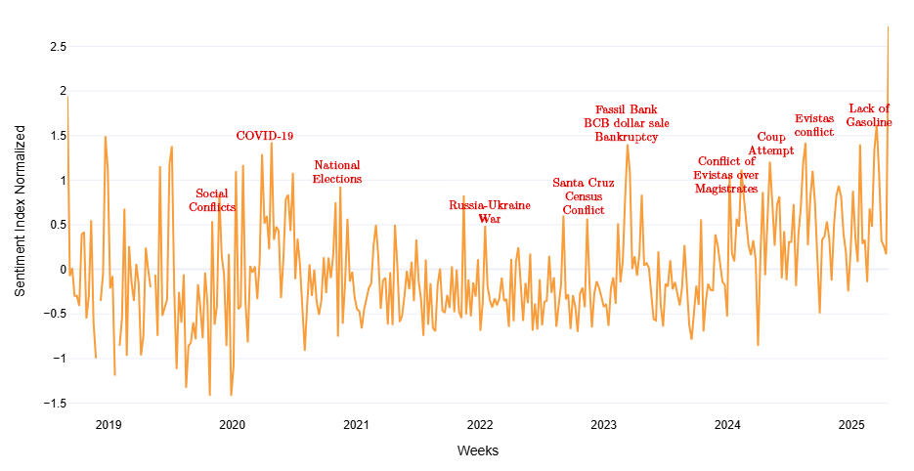

Figure 12: Economic Uncertainty Sentiment Index with Events

To construct the dictionary of terms underlying the economic uncertainty sentiment indicator, we proceeded as follows:

1. **Source selection:** We collected IMF Article IV reports for the period 2015–2020, along with a set of headlines and messages shared in a WhatsApp group dedicated to economic news in Bolivia.
2. **Frequent term detection:** Each document (report or news chat) was subjected to a word-cloud analysis (*WordCloud*). This procedure extracted, for each source, the most frequently occurring words.
3. **Construction of relative frequency tables:** For each report and the WhatsApp corpus, we generated a table listing, for each word, its absolute frequency and its relative frequency for the total number of terms analyzed.
4. **Consolidation and averaging of frequencies:** We merged all tables into a single dataset. We then calculated the mean relative frequency of each term across all sources, ensuring that the dictionary reflects the most persistent concerns over time and across different channels.
5. **Term selection and thematic classification:** We selected those terms whose mean relative frequency exceeded a predefined threshold. These terms were grouped into three thematic categories:
   1. ***Economics:*** *'pib', 'deuda', 'deuda externa', 'usdt', 'bitcoin', 'dólares', 'dólar blue', 'dólar', 'precio del oro', 'tipo de cambio', 'crisis económica', 'crisis', 'gasolina', 'precios', 'inflación', 'reservas', 'rin', 'crecimiento', 'gasto público', 'combustible', 'quiebra', 'importación', 'exportación', 'hidrocarburos', 'diesel', 'filas', 'suben los precios', 'economía', 'económico', 'escasez', 'divisas', 'paralelo'.*
   2. ***Politics:*** *'golpe de estado', 'política', 'banco central', 'gobierno', 'política fiscal', 'corralito', 'intervención', 'elecciones nacionales'.*
   3. ***Uncertainty:*** *'incertidumbre', 'riesgo', 'inseguridad', 'covid-19', 'pandemia', 'coronavirus'.*

The result is a robust, empirically validated term dictionary that serves as the basis for constructing the economic uncertainty sentiment index used in this study.

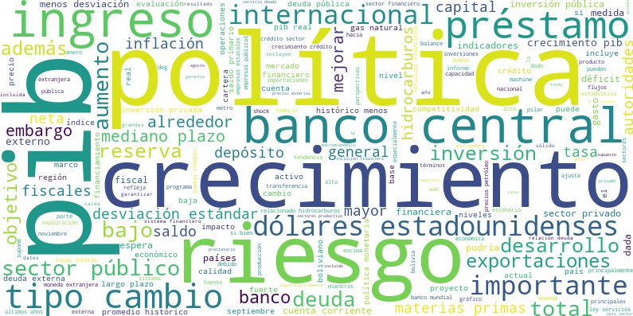 

* + - 1. 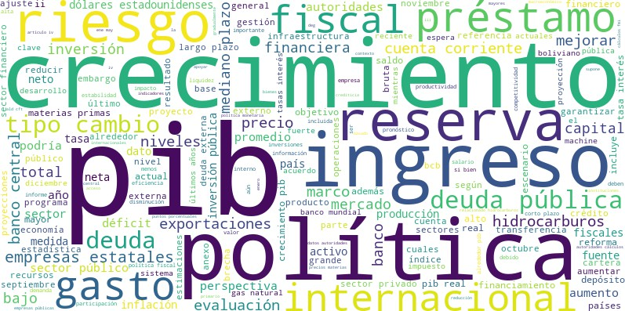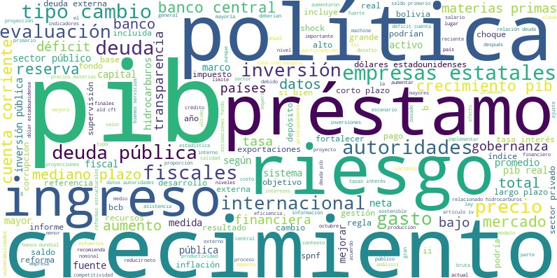Wordcloud 2015 (b) Wordcloud 2016

(c) Wordcloud 2017 (d) Wordcloud 2018

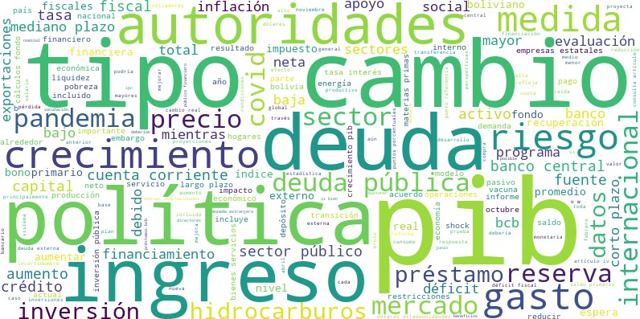 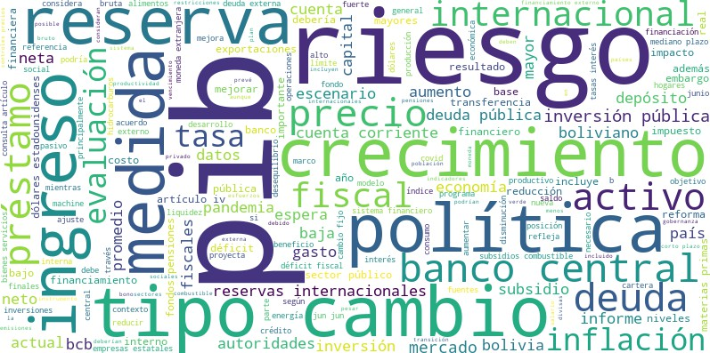

(e) Wordcloud 2019 (f) Wordcloud 2020

Figure 13: Wordcloud by Year

**C Transmission Chanel IRFs: BSVAR Model With 30 Lags**

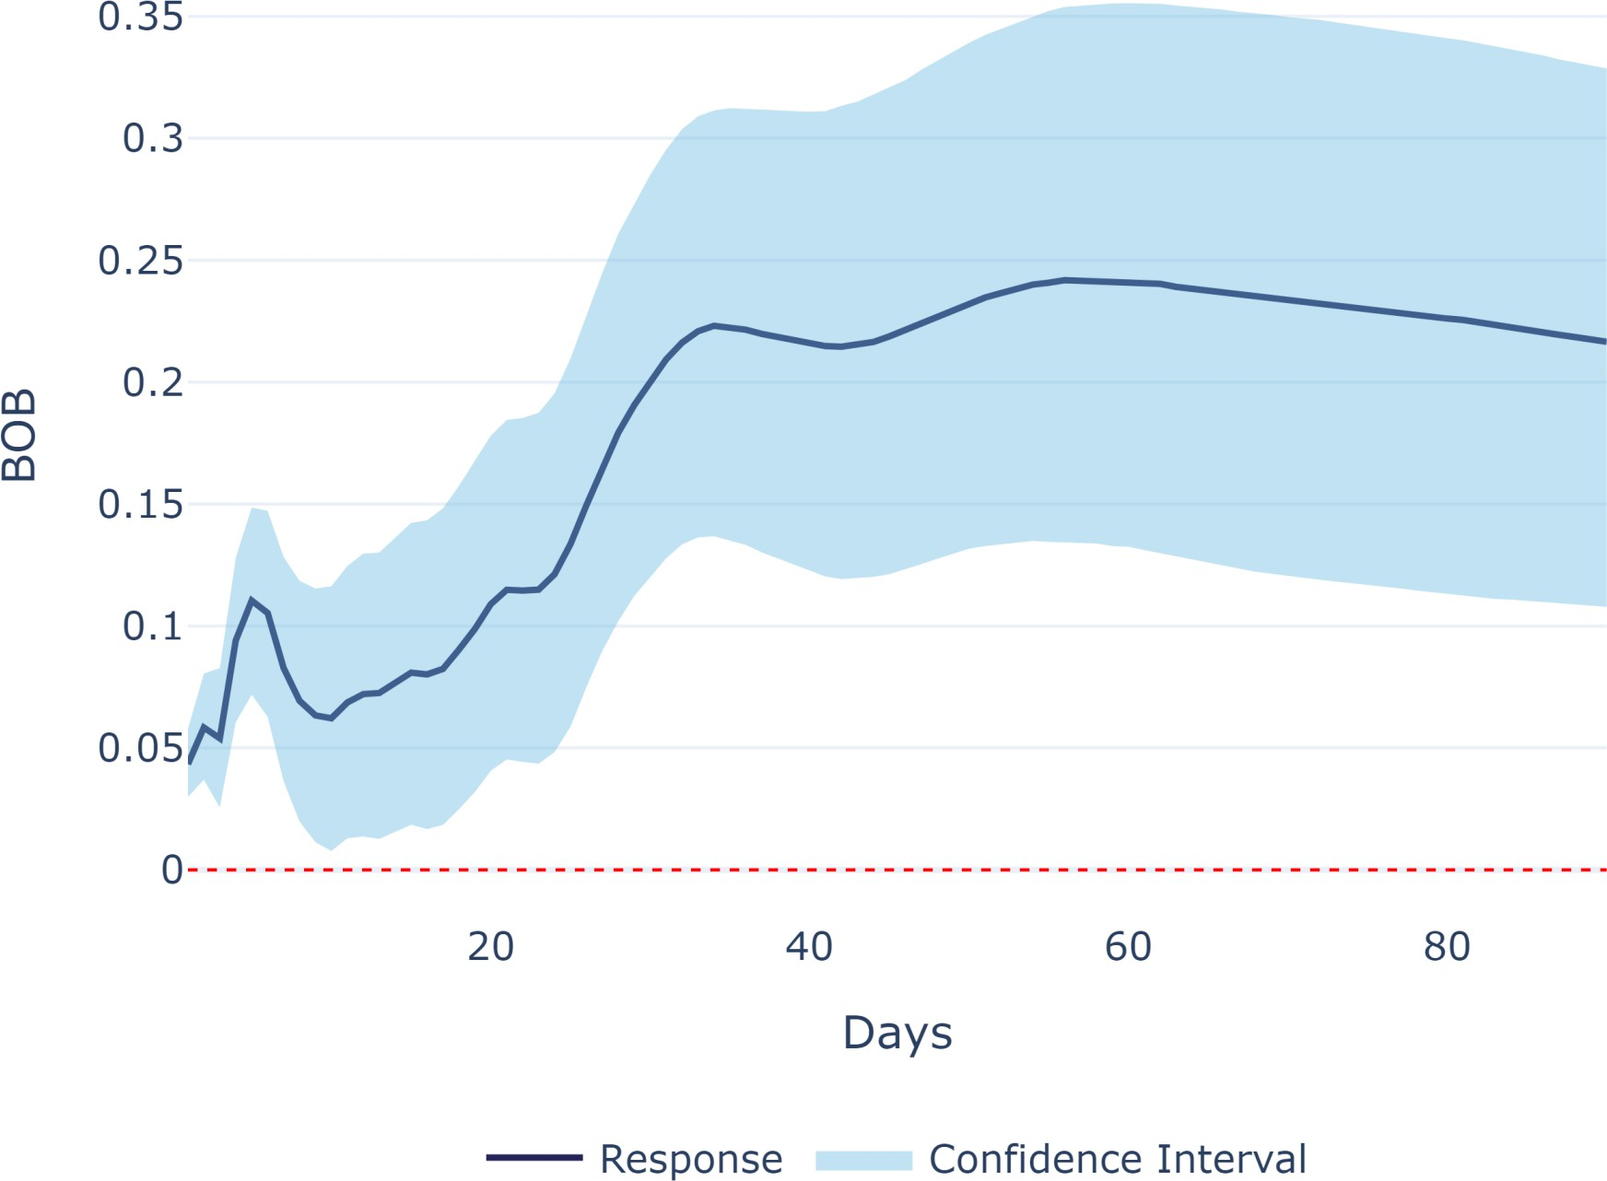

Figure 14: Sentiment (↑ Uncertainty) Shock → BOB/USDT y-o-y Depreciation

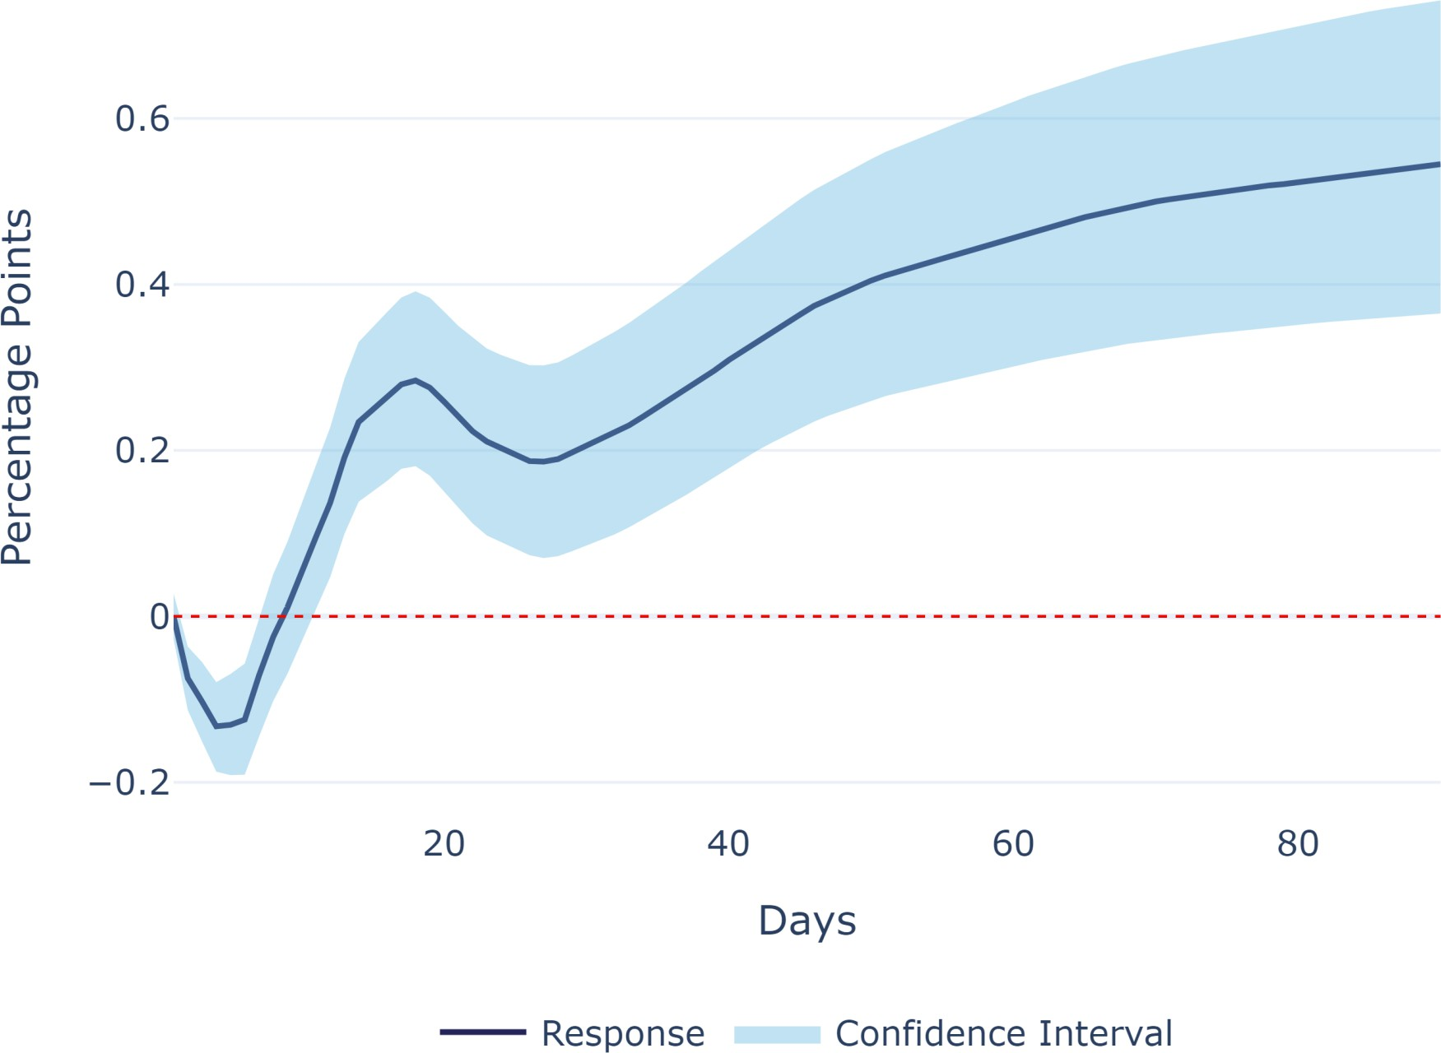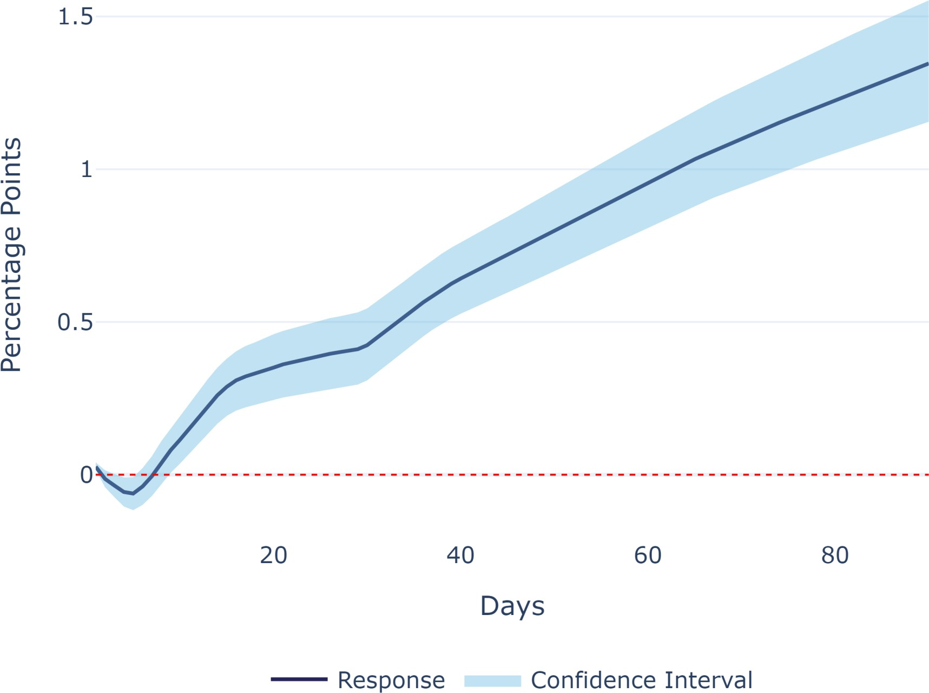

(a) Sentiment (↑ Uncertainty) Shock (b) BOB/USDT Depreciation Shock

Figure 15: Shocks → y-o-y Inflation Forecast

**D Transmission Chanel IRFs: BSVAR Model With Interest Rate**

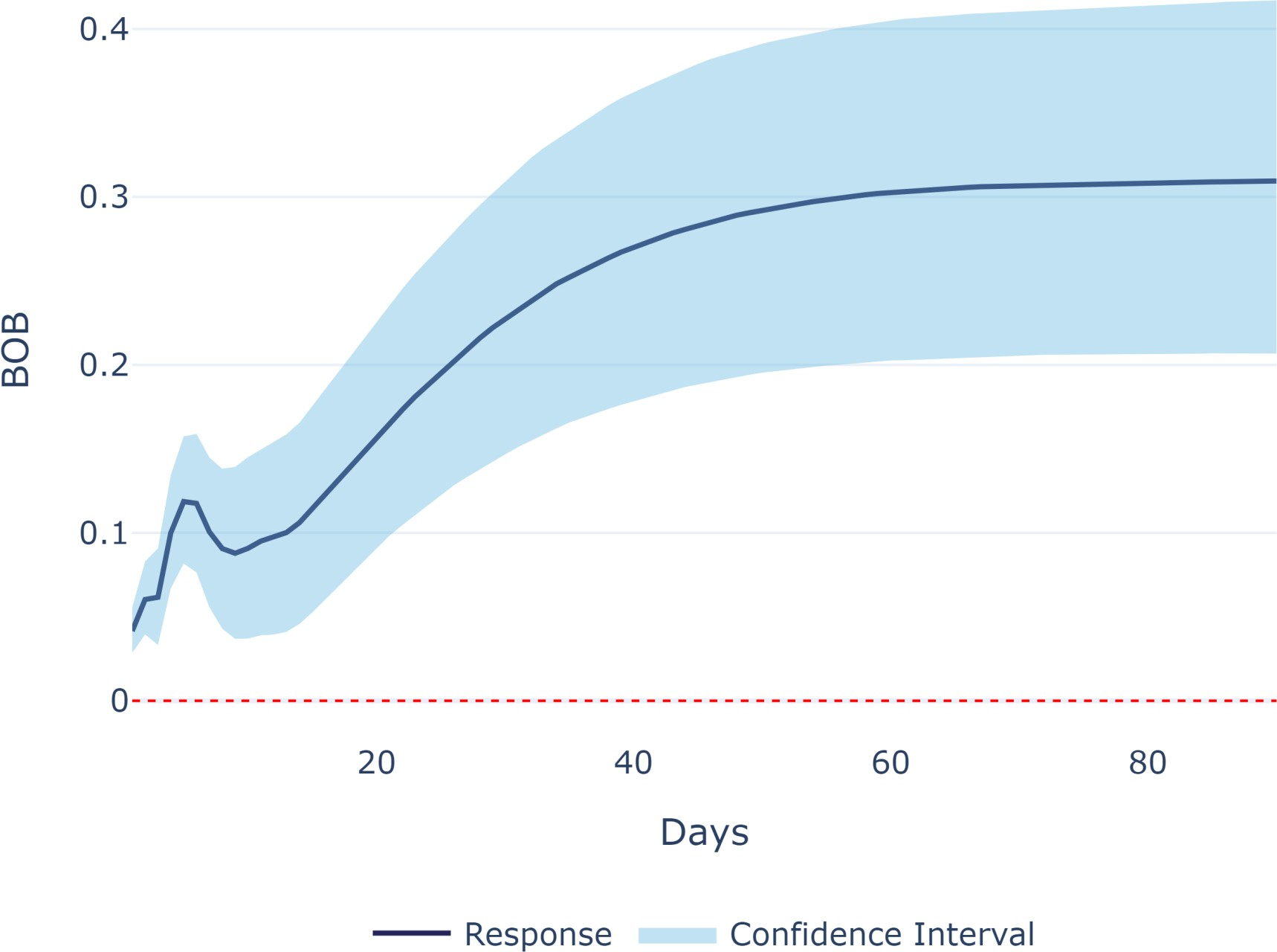

Figure 16: Sentiment (↑ Uncertainty) Shock → BOB/USDT y-o-y Depreciation

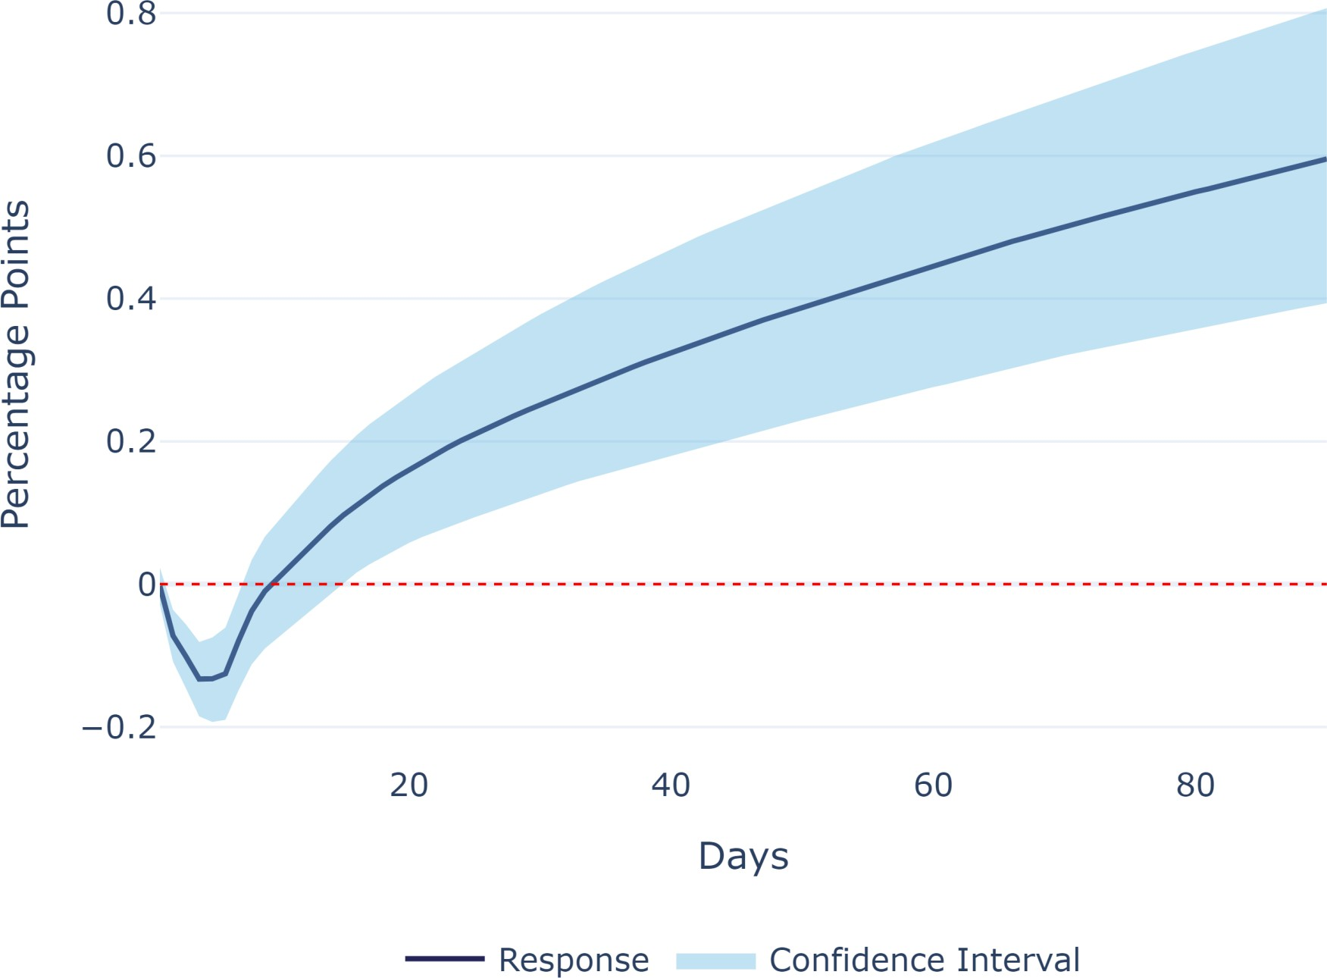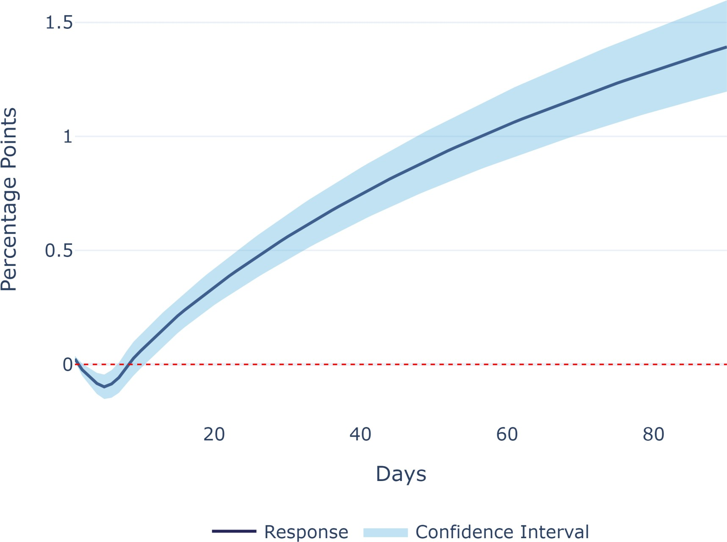

(a) Sentiment (↑ Uncertainty) Shock (b) BOB/USDT Depreciation Shock

Figure 17: Shocks → y-o-y Inflation Forecast

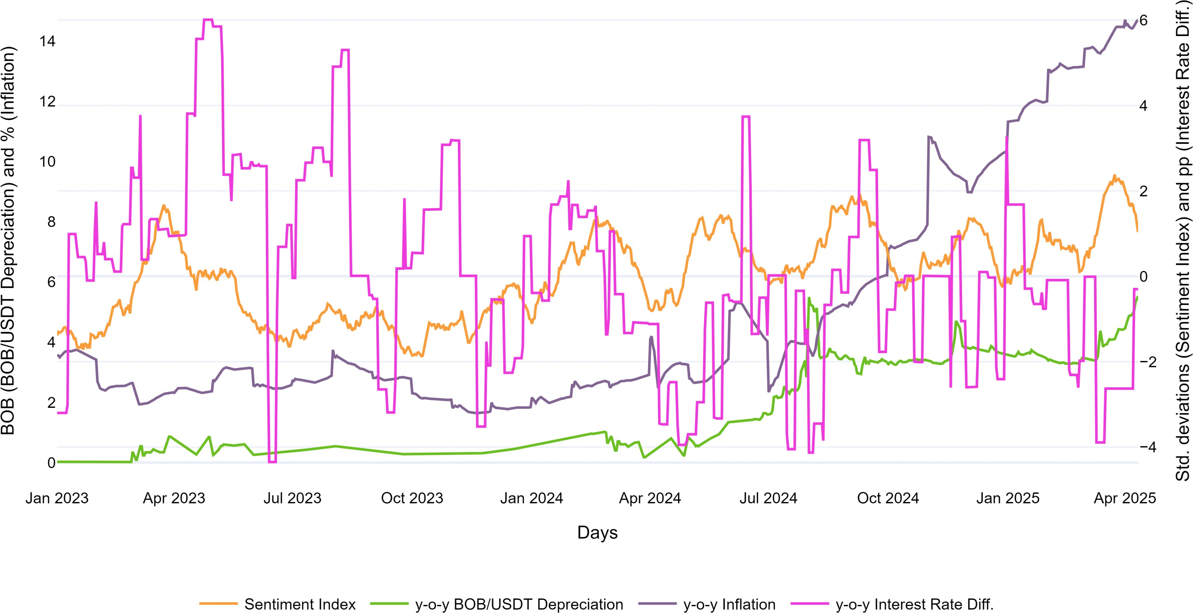

Figure 18: Daily-Frequency Endogenous Variables Transmission Chanel IRFs: BSVAR Model With 30 Lags

1. * The opinions expressed in this paper are those of the authors and do not necessarily reflect the views

   of their affiliated institutions. All remaining errors are our own.
2. ╪ Analytics, Values and Intelligence Laboratory (AVI-Lab). Email: osmar.economics@gmail.com
3. ♠ Ministerio de Economía y Finanzas Públicas. Email: cmhuanto@gmail.com
4. See [La Prensa 2025-04-07](https://laprensa.bo/en-2024-el-dolar-paralelo-fluctuo-entre-bs10-y-bs13).
5. See [La Razón 2025-01-11](https://www.la-razon.com/energias-negocios/2025/01/11/criptomonedas-bolivia-da-el-salto-digital-y-va-por-mas-en-2025/)
6. Data from Bolivia's National Institute of Statistics.
7. See [El Deber 2025-04-24](https://eldeber.com.bo/economia/se-duplico-la-cotizacion-del-dolar-en-el-mercado-paralelo_511924/)
8. Specifically, we use the “*interpolate(method='time')*” function from the pandas package.
9. A working paper is in preparation detailing the full estimation procedure and methodological adaptations for Bolivia.
10. Results of the distributional tests are available upon request.